Participant Information Sheet

 | We are looking for people to take part in the ‘We Need to Talk’ project.
This document will tell you about the project.

It will also tell you how you can take part in the project.
 | Researchers from the University of Queensland are doing this project.
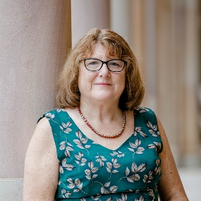 | The researchers are:  - Karen Nankervis
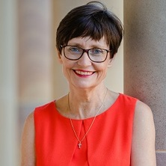 | - Rhonda Faragher
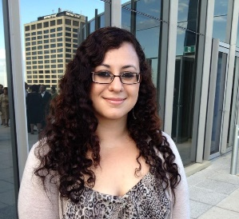 | - Maria Vassos

About the “We Need to Talk” project

 | This project is about genetics and people with disability.
 | Genetics is about how genes are passed from parents to children.
Genes have information that decide:
- What our bodies may look like.
- If we might have health problems.
- If we might have a disability.
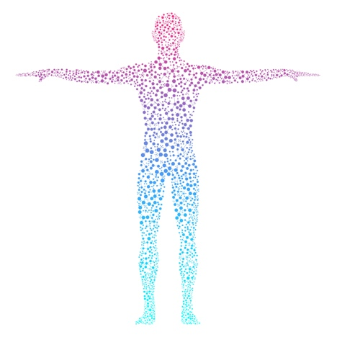 | A person’s body is made of lots of cells.
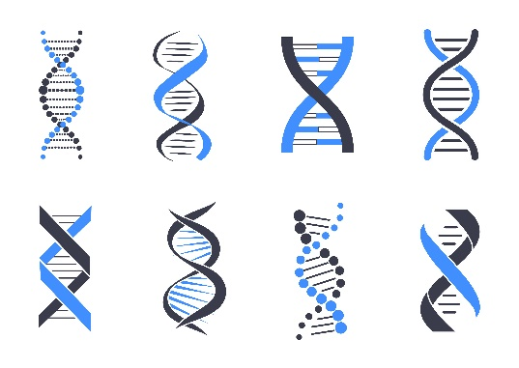 | Genes are found in the cells that make up a person’s body.
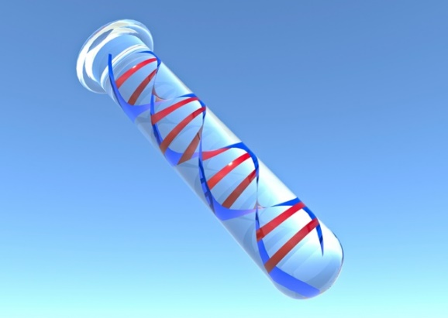 | There are tests that help us to understand a person’s genes.  These tests are called genetic tests.
 | A person’s blood or saliva is tested.
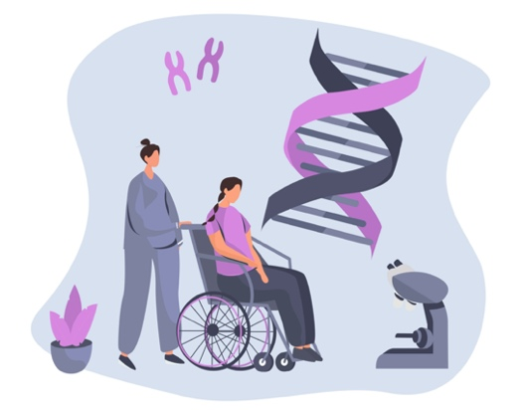 | Some genes can cause a person to have a disability.
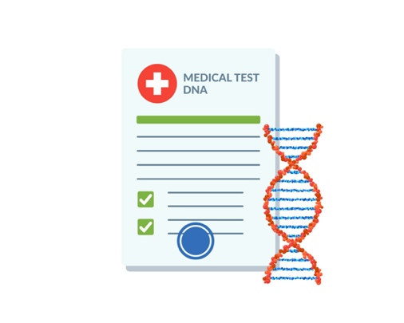 | Genetic tests can tell us if a person has genes that cause disability.
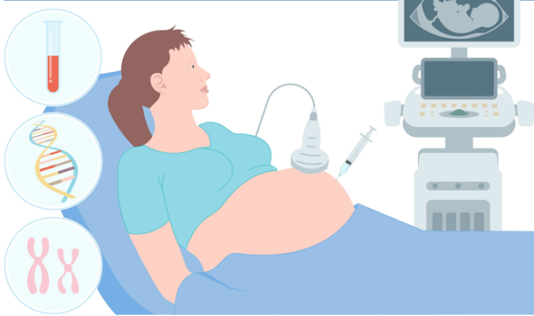 | People of any age can have a genetic test, even unborn babies.

What are we going to do?

We want to know what people with disabilities think about genetic tests.
We will ask people with disability what they think.

I want to participate. What do I need to do?

 | People can choose how they want to tell us about their ideas.
 | People can fill out an online survey.
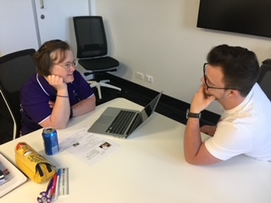 | People can come to an interview to speak about their ideas.
 | The online survey takes between 20 and 30 minutes to complete.
 | If you need help with the online survey, please ask one of your support people to help you.
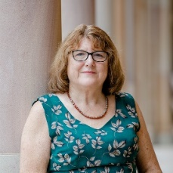 | If you want to participate in an interview, please contact Karen.
 | You can call Karen on (07) 3365 6439.
 | You can email Karen: k.nankervis@uq.edu.au

About the Interview

 | Interviews will last around 60 minutes.
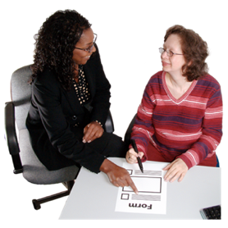 | If you want, you can bring a support person to the interview.
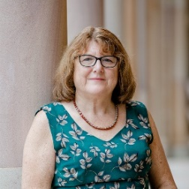  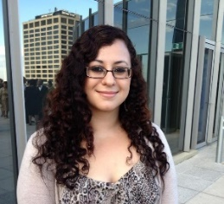 | We can also help you if you need help to talk to us.
 | We can do the interview at a place that you know and feel comfortable in.
 | We can also do the interview online via Zoom.
 | It is OK to say that you do not want to answer a question we ask you.
 | If you feel upset during the interview, please tell us so we can stop the interview.
 | We will audio record your interview.
 | We will listen to the recording of the interview and take notes.
 | We will delete the audio recording after we have taken notes.
 | Any information we collect from you will be kept private.
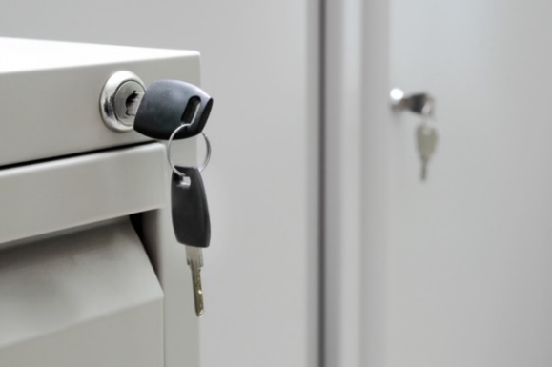 | Information that we write down will be locked in a cabinet that only we can access.
 | If we put any information into a computer, only we can access that computer.
 | All the information we collect will be put together in a report.
 | We will not mention your name in the report.
 | As a thank you, you can enter a raffle to win a $100 Coles Myer gift card.
 | We will put together a summary of findings from the project.
 | If you would like to receive a copy of the summary, you can tell us at the end of your interview.

Do I have to agree to take part?

No, and no one will think badly of you if you do not want to be involved.

IF you say ‘YES’ to being involved:

You can stop being a part of the project at any time.
If you decide to stop, we will not use your information in the project.
You can talk to anyone you want about your interview.

How will this project help people with a disability?

With the help of people with disability, we want to:
Make information sheets about genetic tests.

A fact sheet gives people key information about a topic.

I have questions. Who can I contact?

Karen can answer any questions you have about the project.

You can call Karen on (07) 3365 6439.
You can email Karen: k.nankervis@uq.edu.au
The University of Queensland has said it is OK for us to do this study.

You can also talk to a person from the University of Queensland about this study.
You can ring the Ethics Coordinator on
(07) 3365 3924 or (07) 3443 1656
You can email the Ethics Coordinator:
humanethics@research.uq.edu.au

